Theme: Culture & Society - Social Inequalities

SECTION 1. COMPILATION OF ESSAY QUESTIONS
Questions | Year | Source
Question Focus: Value/Impact
To what extent are people judged more by the physical appearance than by their abilities? | 2017 | A levels
‘Everyone has an opinion but not everyone’s opinion is of equal value.’ What is your view? | 2016 | A levels
Consider the view that some careers are better suited to one gender than the other. | 2014 | A levels
‘The young should never be trusted to make major decisions for themselves.’ Do you agree? | 2022 | VJC Prelims
‘Social causes matter more to the young than the old.’ How far is this true in your society? | 2022 | DHS Prelims
Is the media a boon or a bane to the marginalised? | 2022 | TMJC Prelims
Discuss the claim that the world today is increasingly difficult for the poor. | 2022 | TJC Prelims
Is singlehood still undesirable today? | 2022 | NYJC Prelims
To what extent has progress towards gender equality come at the expense of men? | 2022 | MI Prelims
‘The greatest obstacle to ending social inequality is human greed.’ Do you agree? | 2022 | NJC Prelims
To what extent should disadvantaged groups be given preferential treatment? | 2021 | ACJC Prelims
To what extent has sport made a positive impact in the fight for gender equality? | 2021 | ASRJC Prelims
The fight for human rights has led to more oppression than freedom. What is your view? | 2021 | ASRJC Prelims
Should everyone be treated equally all the time? | 2021 | HCI Prelims
Is it true that the digital age leaves no one behind? | 2021 | JPJC Prelims
Have our efforts to address discrimination made us overly sensitive? Discuss this in relation to your society. | 2021 | RI Prelims
Question Focus: Possibility
To what extent should income equality be a goal in your society? | 2019 | A levels
Evaluate the claim that equality of opportunity for females is a desirable, but unrealistic, goal. | 2016 | A levels
When a government's finances for social welfare are limited, should they be directed towards the young or the old? | 2015 | A levels
How far is increased prosperity for all a realistic goal in your society? | 2013 | A levels
In your society, how far is equality for all a reality? | 2012 | A levels
‘We must eliminate all forms of inequality.’ How realistic is this for your society? | 2022 | HCI Prelims
‘'A society in which no one is left behind.' To what extent is this an achievable goal for your society? | 2021 | CJC Prelims
‘It is impossible to ensure fair rights for all workers.’ Is this a fair comment? | 2021 | JPJC Prelims
Question Focus: Effectiveness
Assess the extent to which different age groups in your society are valued equally. | 2022 | A levels
Evaluate the effectiveness of sport as a platform to tackle social injustice. | 2022 | ASRJC Prelims
‘Not enough action has been taken to meet the needs of women.’ How far is this true in your society? | 2022 | EJC Prelims
Does your society do enough to embrace diversity? | 2020 | EJC Prelims
‘People with special needs are no longer invisible.’ Is this true of the world today? | 2022 | RI Prelims
Assess the view that attempts to fight prejudice can never be truly effective. | 2020 | VJC Prelims
How effective is education in reducing inequality in your society? | 2020 | ASRJC Prelims

SECTION 2. COMMON DEFINITIONS, FEATURES, FUNCTIONS AND CAUSES OF SOCIAL INEQUALITY

1. What is social Inequality?

Social inequality results from a society organised by hierarchies of class, race, and gender that unequally distributes access to resources and rights. It can manifest in a variety of ways, like income and wealth inequality, unequal access to education and cultural resources, and differential treatment by the police and judicial system, among others. Social inequality goes hand in hand with social stratification.

Social inequality is characterised by the existence of unequal opportunities and rewards for different social positions or statuses within a group or society. This brings about unequal distribution of goods, wealth, opportunities, rewards, and punishments.

Social equality is different from social equity. While social equality focuses on providing equal opportunities, social equity goes one step further, taking into account historical and social disadvantages that prevent a level playing field.

There are two main ways to measure social inequality:

(a) Inequality of conditions

Inequality of conditions refers to the unequal distribution of income, wealth, and material goods. Housing, for example, is inequality of conditions with the homeless and those living in housing projects sitting at the bottom of the hierarchy while those living in multi-million dollar mansions sit at the top. Another example is at the level of whole communities, where some are poor, unstable, and plagued by violence, while others are invested in by businesses and the government so that they thrive and provide safe, secure, and happy conditions for their inhabitants.

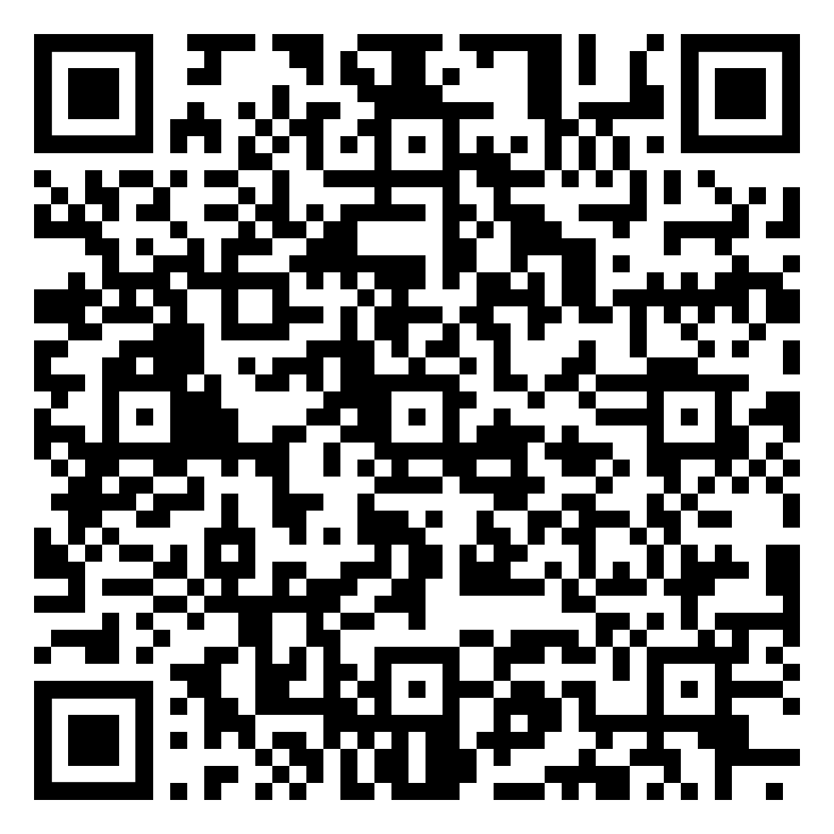
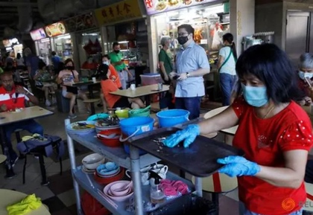
The plight of the low-wage essential wokers.
Singapore’s emphasis on paper qualifications has led to an unequal society where blue collar jobs are looked down upon and paid less compared to white collar jobs. In the 2021 Budget Debate, Members of Parliament discussed what can be done for low-wage essential workers. MPs suggest better pay for essential low-wage workers, unemployment insurance during Budget debate CNA, 21 Feb 2021

(b) Inequality of opportunities

Inequality of opportunities refers to the unequal distribution of life chances across individuals. This is reflected in measures such as level of education, health status, and treatment by the criminal justice system. For example, studies in the United States have shown that college and university professors are more likely to ignore emails from women and people of colour than they are to ignore those from white men,﻿ which privileges the educational outcomes of white men by channelling a biased amount of mentoring and educational resources to them.


Inequality of opportunities for females.
Around the world, girls and women constantly receive the message that their primary role should be that of caregiver. Given these perceptions, families and communities are less likely to place a high priority on girls’ education. The World Values Survey found that one in four people worldwide still believe that a university education is more important for a boy than for a girl. This severely limits opportunities for women in education. Getting girls into schools is only the start of closing the education gap, 9 Aug 2019

2. What are some common terms used in social inequalities?

Stereotypes | - Fixed, commonly held ideas or images of a person or group, based on an oversimplification of some observed or imagined trait of behaviour or appearance.  - Ignore the uniqueness of individuals by painting all members of a group with the same brush.  - Can be positive, negative, or neutral.  - Runs the risk of becoming prejudicial and leading to discrimination.
Prejudice | - A hostile feeling or attitude regarding a group of people  - Exists in the mind and is unseen until it is acted upon. Prejudice and discrimination are closely related because prejudice becomes discrimination when acted upon.
Discrimination | - The treatment of, or making a distinction in favour of or against, a person or thing solely based on the group to which that person belongs rather than on individual merit.
Positive Discrimination / Affirmative Action | - An approach where steps/policies are enacted by governments or companies to favour groups that have been discriminated against previously – eg. women and ethnic minorities  - This could be in the area of employment, education, business, or the allocation of resources

3. Why do social inequalities exist in society?

Forming differential perceptions of others and treating them as such based on these perceptions help people make sense of and deal with the world around them.

Functions of Stereotypes, Prejudice and Discrimination

Stereotypes | - They allow people to quickly process new information about an event or a person.  - They organise people’s past experiences.  - They help people to meaningfully assess differences between individuals and groups.  - They help people to make predictions about other people’s behaviour so they can pre-empt and act accordingly.
Prejudice | - Prejudice gives people scapegoats to blame in times of trouble. It is often employed as a self-defence mechanism to avoid self-doubt and fear.  - Prejudice can boost one’s self-esteem.  - Prejudice allows people to bond with their own group by contrasting their own groups with outsiders.  - Prejudices legitimises discrimination because it apparently justifies one group’s dominance over another.
Positive  Discrimination/ Affirmative Action | - When people recognise that certain groups of people lag behind in society, they provide special benefits to these groups to meet their identified needs with the intention of reducing the disadvantage experienced these groups.  - By doing that, they improve the equality of opportunity for people based on their race, disability or sex.

In fact, our perception of others is often based on their biological differences or shaped by social influences. However, not many are aware that these perceptions are actually immediate, questionable generalisations.

Nature: Assumptions based on biological appearances
As human beings, it is almost instinctive to make assumptions about others when we first meet them. We often make these assumptions based on a person’s observable biological profile – such as their gender, race, age group, etc.
- We tend to subconsciously note these details about people we first meet them, as it helps us understand how to interact with or behave around them. This is especially so when we meet those who appear different from ourselves.
- Once we have identified another person’s profile, we tend to make immediate, questionable generalisations about them:
  - E.g. Age Group: Youth immature, reckless, self-centred
  - E.g. Gender: Women emotional, bad at driving, hopeless at mathematics

Nurture: Social influences
However, while it seems to be a natural human instinct to make such assumptions, our perceptions of others are also shaped by social influences.
- Children form perceptions of different groups of people based on how they were raised. These perceptions about others may carry through to adulthood.
- In her book Understanding Race, Ethnicity and Power: The Key to Efficacy in Clinical Practice, Elaine Pinderhughes wrote that many of the white individuals she interviewed were taught to fear the blacks as children, as they were often described as threatening and suspicious. They were also influenced by their parents’ hostile treatment of the blacks.

- The mass media tend to continuously portray groups of people in a simplified or exaggerated way, sometimes causing us to internalise and believe in these images.
  - Gender stereotypes: Though images of women have grown in diversity over the years, some would argue that women are often portrayed as weak and helpless “damsels in distress”. In contrast, men are more likely to be portrayed in a positive light as the main protagonist.
  - Racial stereotypes: Black people in the media are often portrayed as violent, dangerous and uneducated criminals. Asians are typically portrayed as smart, cunning and hardworking.

- Stereotyping and prejudice begin from social categorisation—the natural cognitive process by which we place individuals into social groups. Categorisation is a process whereby we make sense of the world around us by separating things into different classes or groups. When we learn which categories that objects belong to, we also learn about relationships between those objects. Social categorisation involves applying that same process to people, including ourselves. It is not only a cognitive process for understanding and explaining the world, but it is part of the way we organise the world. That is, the groups we belong to such as genders, ethnicities, religions, and nations are based on social categories, and thus phenomena such as stereotyping and person perception rest on social categorisation.
- When we categorise other people, we tend to see people who belong to the same social group as more similar than they actually are, and we tend to judge people from different social groups as more different than they actually are. The tendency to see members of social groups as similar to each other is particularly strong for members of outgroups, resulting in outgroup homogeneity—the tendency to view members of outgroups as more similar to each other than we see members of ingroups.
- Once we begin to see the members of outgroups as more similar to each other than they actually are, it then becomes very easy to apply our stereotypes to the members of the groups without having to consider whether the characteristic is actually true of the particular individual. If men think that women are all alike, then they may also think that they all have the same positive and negative characteristics (e.g., they are nurturing, emotional). And women may have similarly simplified beliefs about men (e.g., they are strong, unwilling to commit). The outcome is that the stereotypes become linked to the group itself in a set of mental representations. The stereotypes are “pictures in our heads” of the social groups. These beliefs just seem right and natural, even though they are frequently distorted overgeneralisations.
- Once our stereotypes and prejudices become established, they are difficult to change and may lead to self-fulfilling prophecies, such that our expectations about the group members make the stereotypes come true.

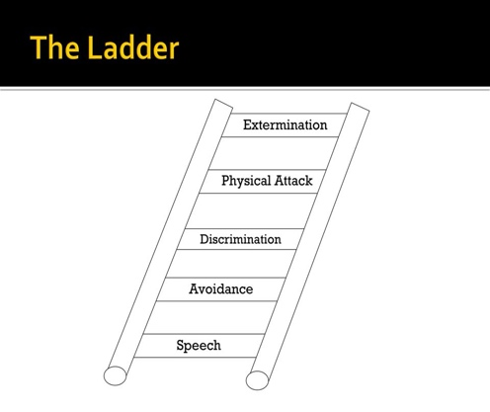
When stereotyping of others leads to distorted generalisations, it can lead to prejudice which brings about active discrimination of others, contributing to social inequality.

DEGREE OF DISCRIMINATORY ACTS

- Speech: Making negative verbal remarks against a person or group
This refers to discrimination in the form of speech made freely and informally, usually as casual remarks or jokes. Such speech can be seen as inappropriate, mildly offensive or even derogatory and may happen privately or in public, but not directly to an intended target.

- Avoidance: Staying away from a person or group
Like speech, this seems harmless in the beginning. One has the right to choose one’s friends, and choosing not to be friends with a particular group of people does not seem so awful. Even though no harm is directly inflicted on the group being avoided, there is harm from the isolation and social exclusion which arise. Furthermore, lack of contact and friendship with a group leads to ignorance about them. Ignorance, in turn, leads to stereotyping, fear, and prejudice.

- Discrimination: Denial of opportunities and services
Avoidance leads to the third rung, discrimination. The unwanted groups are now kept out of some neighborhoods, shopping areas, social clubs, schools, churches, gathering places, and public centers. Laws are enacted to enforce this discrimination and make it legal for society to discriminate. When this happens, discrimination becomes institutionalised.

- Physical attack: Violence against a person or group
Such physical attack may be a mob’s expression of anger or resentment. It may take the form of gang warfare resulting from prejudice, or it may take the form of defacing buildings or places of worship. Physical attack includes all violence to people or property based on hatred, fear, ignorance, and revenge. (When institutional racism is prevalent in a society, physical attack is likely to go unpunished and may even be encouraged.)

- Extermination: Elimination of a significant fraction of a particular group
Extermination is the most drastic form of discrimination of all, and it involves the removal of an entire group of people. Significant examples are the systemic extermination of Jews under Nazi Germany, ethnic genocide in Rwanda, ethnic cleansing in the Bosnian War and mass killings of the Rohingya people in Myanmar.

Other than stereotyping and discriminating against others, there are also other social factors that contribute to inequality.

Social Factors that Contribute to Inequality
Unemployment or having a poor quality (i.e. low paid or precarious) job | This limits access to a decent income and cuts people off from social networks.
Low levels of education and skills | This limits people’s ability to access decent jobs to develop themselves and participate fully in society.
The size and type of family | Large families and lone parent families tend to be at greater risk of poverty because they have higher costs, lower incomes and more difficulty in gaining well paid employment.
Gender | Women are generally at higher risk of poverty than men as they are less likely to be in paid employment, tend to have lower pensions, are more involved in unpaid caring responsibilities and when they are in work, are frequently paid less even for the same job.
Disability or ill-health | This limits ability to access employment and also leads to increased day to day costs.
Being a member of minority ethnic groups and immigrants/undocumented migrants | They suffer particularly from discrimination and racism and thus have less chance to access employment. They are also often forced to live in worse physical environments and have poorer access to essential services.
Living in a remote or very disadvantaged community | Access to services is poor in such communities.

SECTION 3. IMPACTS OF SOCIAL INEQUALITY

Very frequently, the consequences associated with social inequality are measured in economic terms, capturing the gap in income and wealth distribution between the haves and the have-nots. The most widely used measure of inequality is the Gini coefficient, which ranges from 0 (perfect equality) to 1 (perfect inequality, one individual has everything). It is also expressed as a percentage, with 0% reflecting perfect equality, and 100% reflecting its opposite. However, this is an imperfect measure that:
- Does not take into account the country’s overall wealth and income (ie extent of distribution of wealth to support basic living standards.) This means that both developed and developing nations can have the same Gini coefficient.
- It also does not reflect how in many cases, social inequality can stem from, and exacerbate racial and ethnic inequality, gender inequality, and other forms of discrimination.

Social inequality has also worsened due to the nature of our modern world. Globalisation, coupled with the advancement in technology, have enabled the elites to amass even more wealth, thereby perpetuating a vicious cycle where the have-nots are further deprived of opportunities and hence, further marginalised. As such, impacts of social inequality are often diverse and can overlap.

RACIST ACTIONS

Racism can be defined as a conscious or unconscious belief in the superiority of one race over another. This definition presupposes the existence of different biologic ‘races’, a supposition now dispelled by recent research, especially the Human Genome Project. However, although ‘race’ is clearly a social construct (created by society and not natural), racism is nonetheless prevalent throughout the world.
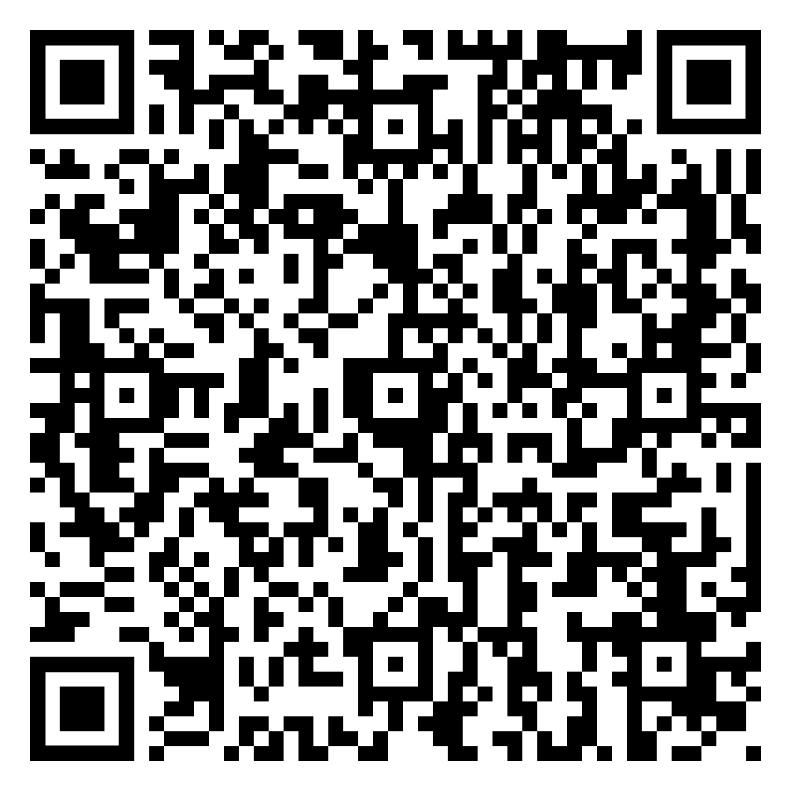
Racism of any kind is related to power, with people who hold power determining what is ‘superior’ and discriminating against people with less power (privilege). Many people today continue to practise cultural racism or ethnocentrism, believing that some cultures (usually their own) are superior or that other cultures, traditions, customs and histories are incompatible and inferior as compared to theirs. The consequences of racism can be devastating both for individuals and for society as a whole. Oppression based on racial differences has ensured the subjugation of many to the whims of a tiny minority who hold wealth and power in some societies. It has also withheld economic opportunities and access to better paying jobs from those who are considered racially ‘inferior’. In extreme cases, racism has even led to mass extermination and genocide.

Younger people more likely to see racism as important problem, feel existence of majority privilege: CNA-IPS survey

Case Study: Anti-Semitism
Anti-Semitism, or hostility towards Jews as a religious or ethnic minority, dates from medieval times when Jews were usually the only non-Christian minority living in Christian Europe. Typically prohibited from practising most trades and professions, forced to live in ghettos apart from Christians, penalised with high taxes, stripped of property and even expelled from their countries or killed, Jews struggled for centuries against the injustice and prejudice of Christian societies. The rise of fascism in the mid-twentieth century, with its ideology of racial superiority, intensified anti-Semitism in Europe and ultimately resulted in the Holocaust, the systematic extermination of more than six million Jews during the Second World War. In the twenty-first century, anti-Semitism is far from over. Groups claiming their superiority desecrate Jewish cemeteries and neo-Nazi networks openly circulate anti-Semitic propaganda. Just recently in 2020, a Jewish student filed a lawsuit against the elite New Jersey high school, describing her three years of anti-Semitic harassment.

XENOPHOBIA

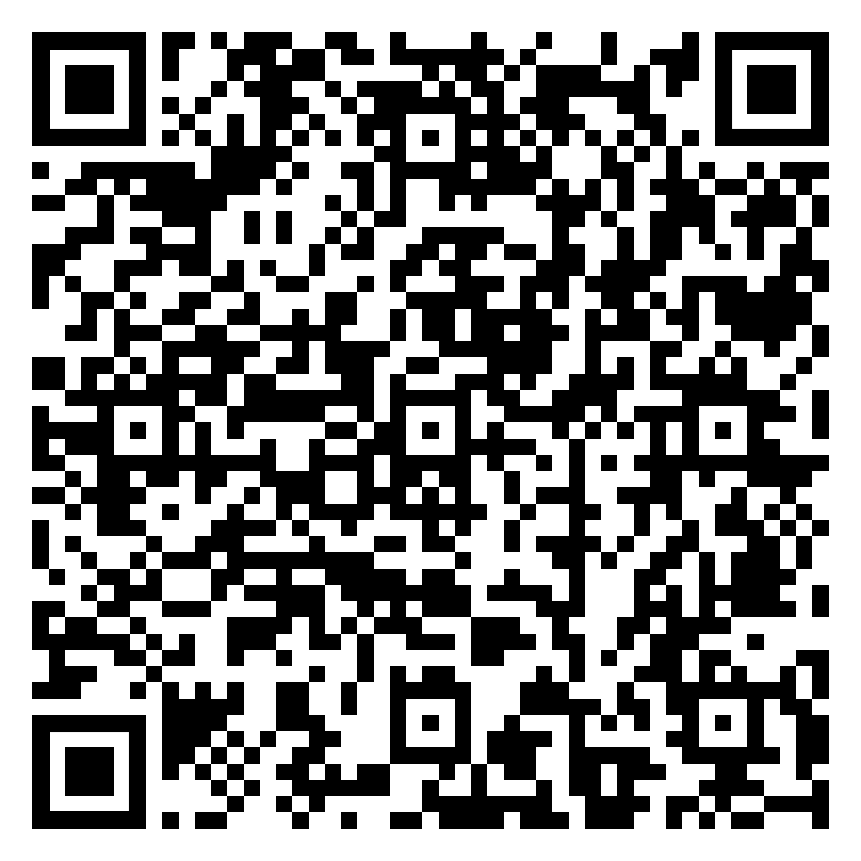
Some people respond to increased globalisation and diversity of society with xenophobia: a fear of or aversion to foreigners. In most cases the concept of ‘foreign’ is once again frequently based on socially constructed images and ideas that reduce the world to ‘us’ – the normal, ‘good ones like me’ versus ‘them’: the others who are different, a threat or disruption, representing a degradation⁺ of values and proper behaviour.

IPS Study Finds Most Singaporean Residents, Especially Older Ones, Want Strict Limits on Inflow of Foreigners

2022

Although most people consider this aversion to be morally unacceptable, it is not unusual. Xenophobia also overlaps with racism, as xenophobic individuals tend to identify and marginalise others based on observable traits such as skin and hair colour, and their spoken accent. Discriminatory actions based on xenophobia, such as verbal abuse and acts of violence, which are clearly human rights violations, still occur today in various parts of the world. Unfortunately, xenophobia can also structural, and can be seen in the systematic exclusion of individuals of that specific group from benefits such as health care, housing, employment, and legal representation.

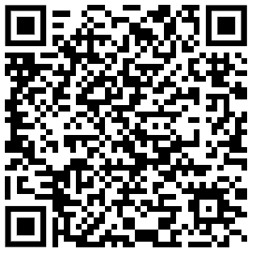Note: Students tend to conflate the term ‘foreigners’ with ‘foreign workers’. You should note that the former term is much broader in definition and includes tourists as well as expatriate workers.

SEXIST ACTIONS

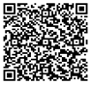
Although subtle and more or less hidden, gender discrimination is nonetheless pervasive. Many institutions of society, such as the media, family, childcare institutions or schools, preserve and transmit stereotypes about men and women. Traditional gender traits in societies often relate to power: men and their typical activities are characterised as outgoing, strong, productive, brave, important, public-oriented, and influential and having high financial rewards, social recognition and value. On the other hand, women’s key characteristics reflect powerlessness: dependent, caring, passive and family-oriented. Women often hold subordinate positions, and their work is less valued and it receives less recognition and remuneration. For both genders, individuals who do not conform to stereotypical expectations can experience criticism, ostracism and even violence. Such conflicts can confuse the development of children’s gender identity.

Singapore women have more equal opportunities, but some way to go for equitable⁺ outcomes

Worldwide optimism about future of gender equality, even as many see advantages for men


RELIGIOUS INTOLERANCE

Freedom of religion is officially respected in most countries, yet discrimination based on religion is nevertheless prevalent, often inextricably linked with racism and xenophobia.
Business interests vs religious freedom in the EU
Of particular concern is the rise of Islamophobia: the discrimination, fear and hatred of Islam. The hostility towards Islam following the terrorist attacks on targets in the United States, Spain and England in recent years has revealed deep-seated prejudices in most European societies. Some of the most common public expressions of this bias are a lack of official recognition as a religion, the refusal of permission to build mosques, failure to support facilities for Muslim religious communities and restrictions on women wearing the headscarf. Prejudice also results from ignorance about Islam, which many people associate only with terrorism and extremism and politics of certain countries. In fact, Islam, like most religions, preaches tolerance, solidarity and love for one’s fellow beings.

Case Study: Christchurch Mosque Attacks
The association of Muslims with the terrorists of the 9/11 attack on World Trade Centre, Al-Qaeda and ISIS has led to negative attitudes towards Muslims across the world. The spread of Islamophobia is linked to the negative portrayal of Muslims in the media, creating social panics in many countries towards Muslims. This has resulted in discriminatory acts against Muslims in public spaces, hate speech in social media and violent attacks. Numerous attacks have occurred on mosques across the globe highlighting the phobia against Muslims ranging from spraying graffiti, arson to shootings. The 2019 attack on mosques in Christchurch, New Zealand (2019) was committed by an individual who had extreme conservative views. He became obsessed with terrorist attacks committed by Islamic extremists and started planning an attack about two years prior to the shootings.

SEXUAL PREJUDICE AND HOMOPHOBIA

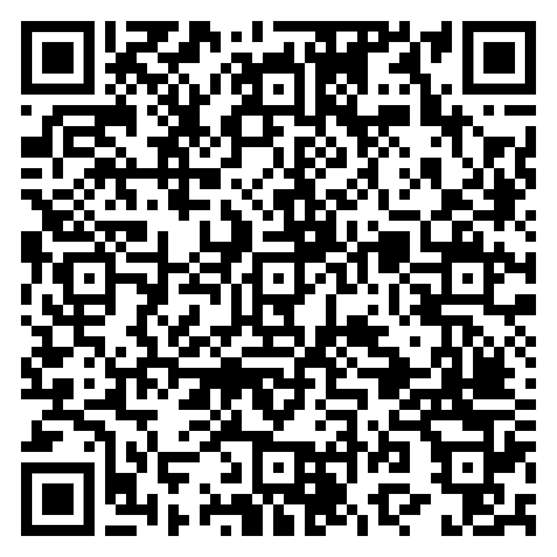

Sexual prejudice is a broad term that refers to all negative attitudes based on sexual orientation, whether the target is homosexual, bisexual, or heterosexual. However, given the predominant heteronormative bias that underpins society today, such prejudice is almost always directed at people who engage in homosexual behaviour or label themselves gay, lesbian, or bisexual. Homophobia is a more extreme term that refers to an aversion to or hatred of gay, lesbian or homosexual people, or their lifestyle or culture (or generally of people with a different sexual orientation, including bi-sexual and transgendered people). Although legal reforms have greatly strengthened the human rights of gay and lesbian people, conditions vary greatly, from cities where homosexual people live and work openly, and form civil unions with relatively little difficulty to places where gays may meet with discriminatory laws, harassment and even violence from both the public and authorities. As such, many choose to remain “in the closet”, concealing their sexual orientation from many, or most people in their lives. This has wide ranging implications, from preventing them from publicly showing their affection to their partners, to mental health issues that arise from having to function in social and professional environments that are dominated by heterosexual norms.
Supreme court delivers major victory To LGBTQ employees

ABLEISM
$125 Million Verdict Against Walmart In Disability Discrimination Case

The term ‘person with a disability’ may refer to many different conditions: a disability may be physical, intellectual, sensory or psycho-social, temporary or permanent, and result from illness, injury or genetics. People with disabilities have the same rights as all other people.

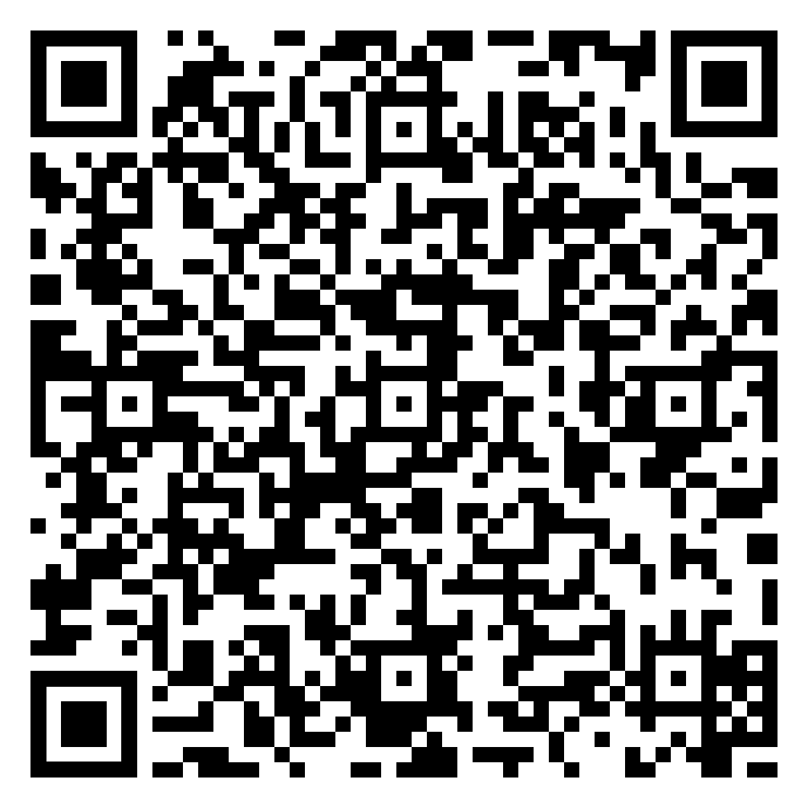
However, for a number of reasons, they often face social, legal and practical barriers in claiming their human rights on an equal basis with others. These reasons usually stem from misperceptions and negative attitudes toward disability itself; with the belief that people with disabilities cannot be productive members of society as they are ‘broken’ or ‘sick’ and require fixing or healing, or that they are helpless and need to be cared for. Instead, a positive attitude regards disability as a natural part of human diversity that should be approached with reasonable accommodation, which is any measure designed to promote full participation and access, and to empower a person to act on his or her own behalf. This positive approach suggests that society has a responsibility to accommodate the person with disabilities.
Are employees with disabilities neglected in Singapore?

AGEISM

Age discrimination involves treating individuals less favourably because of his or her age. Also known as ageism, it refers to any stereotyping and discrimination against individuals based on their age. This term was coined by Robert Butler, a psychiatrist, in 1969, who referred the negative attitude to three connected elements: old age, older people; and ageing process which includes discriminatory practices against older people; and institutional practices and policies that perpetuate stereotypes about elderly people. Ageism can occur in work places where older employees are not treated fairly by denying job opportunities, promotions or even wrongful dismissal. Age discrimination persists even though older workers are not necessarily less healthy, less educated, less skilful or productive than their younger counterparts. It can also cut both ways, penalising also the younger generations such as the Millennials and Gen Zs, who are perceived as ‘too entitled’.

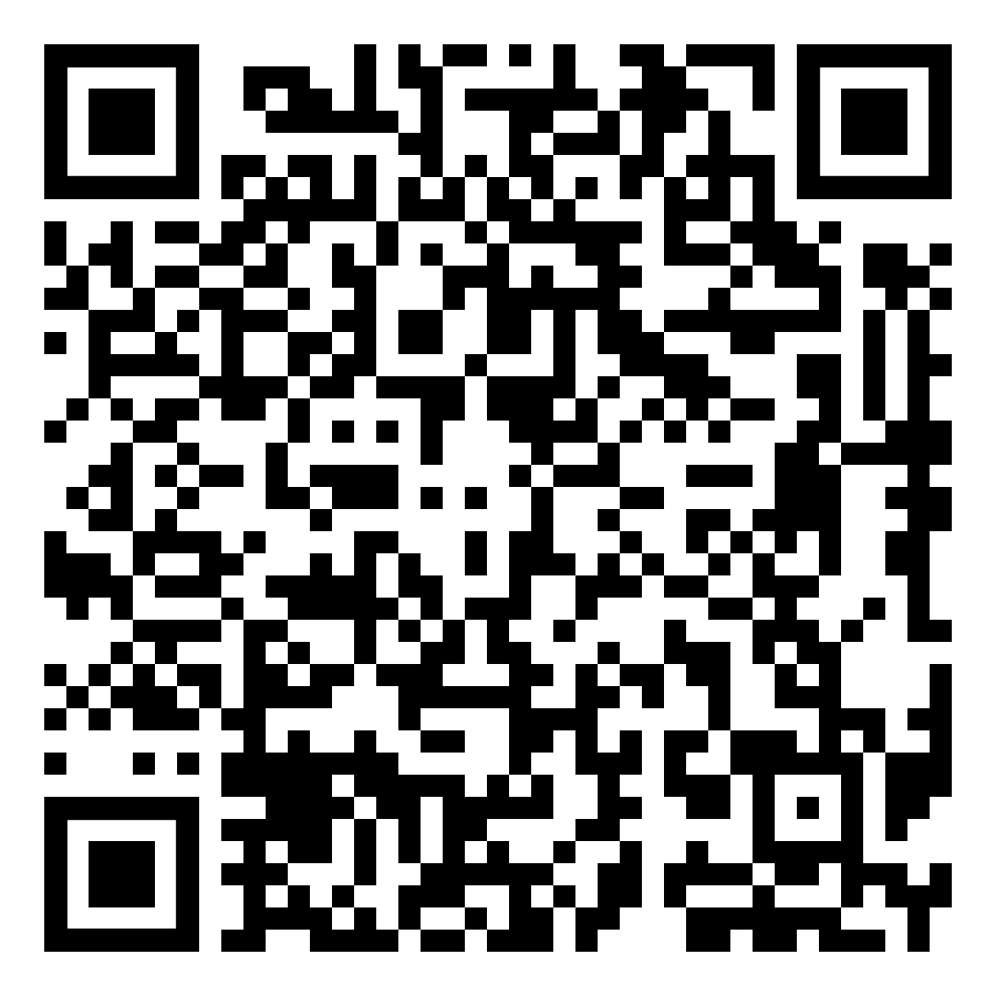
Ageism hurting young workers
Why is it still considered OK to be ageist?

SECTION 4. SOLUTIONS

The complex manner through which social inequality is manifested means that solutions are seldom straightforward; solutions to social inequality cannot just stop at the level of regulation. Only the sustained and collaborative efforts of various stakeholders will allow us to create greater equity for all. It is also worth noting that while some of these efforts and initiatives may begin with good intentions, they can sometimes backfire and exacerbate inequality instead.

Case Study 1: Greater Equality for Lesbian, Gay, Bisexual, Transgender and Queer (LGBTQ)
Individuals in the US
LGBTQ individuals in the US have long been discriminated against – they have been stereotyped and have experienced ostracism, denial of rights, and even violence. However, in recent times, the hostility towards the community has mellowed. While LGBTQ discrimination still exists in the US, the public has increasingly extended acceptance towards this community. This positive shift in public opinion and the country’s treatment of the LGBTQ community cannot be attributed to one sole stakeholder but a collective effort by multiple parties.
Stakeholder | Efforts
Government  The state passes the laws by which citizens are to abide, allowing them to shape institutions and people. Governments can address social inequalities through its laws and policies – ensuring that all people have equal access to opportunities, goods and services. | Firm action by the US government since the 1990s have helped to remove legal barriers to equality:  - In several US states, same-sex marriages and same-sex adoption have been legalised. Conjugal visits can be granted to gay couples by law.  - Historically, Title VII of the Civil Rights Act of 1964 has made it illegal for employers to discriminate because of a person’s sex. In June 2020, the US Supreme Court ruled that Title VII also specifically covers sexual orientation and transgender identity, thereby protecting LGBT people from discrimination by employers
Non-Governmental Organisations  Non-governmental organisations (NGOs) supplement governmental efforts to support discriminated groups. | - The Human Rights Campaign (HRC) has more than 1.5 million members and supporters across the nation and collaborates with different stakeholders to fight for LGBTQ equality. One of their ongoing projects is Count Me In, a campaign that mobilises LGBTQ individuals and allies to advocate for and spread awareness on behalf of transgender and non-binary people.
Media  The mass media are an important vehicle of social and cultural ⁺integration. The wide reach of the mass media also amplifies the influence necessary to address issues of discrimination. | - Prolific celebrities, including some who are part of the LGBTQ community (such as Ellen DeGeneres), openly speak about and champion LGBTQ rights on various talk shows and social media platforms.  - Recurring or even regular homosexual characters in mainstream shows such as Grey’s Anatomy and Modern Family normalises homosexual relationships, influencing the public’s acceptance of the LGBTQ community.
Corporations  Many companies fulfil their Corporate Social Responsibility (CSR) by advocating for marginalised groups in society. Some companies are well-known for their social actions, which become part of their brand. | - Nike, a big stakeholder in the athletics apparel industry, holds an annual #BeTrue campaign during Pride Month where it releases a series of limited edition, rainbow-gradient apparel and shoes to advocate its support for the LGBTQ community  - Apple released two new Apple Watch Pride bands as well as a new Pride watch for users in 2021 in support of the LGBTQ community. The brand also supports a number of LGBTQ advocacy organizations such as Encircle, which offers safe spaces for LGBTQ youth, young adults and families.
Individuals  ‘Bystander actions’ are actions taken by individuals who are neither direct targets of nor perpetrators of discrimination to speak out about or engage others in responding against discrimination of any form. | - Americans show an increased empathy for and solidarity with the LGBTQ community. Such strong public opinion has the power to influence more Americans and may even affect future legislation regarding LGBTQ rights.  - Thousands of Americans show their support during Pride Month by overlaying their Facebook profile pictures with the six-coloured rainbow flag. They also join the LGBTQ Pride March that takes place in various cities every year to lend their support.
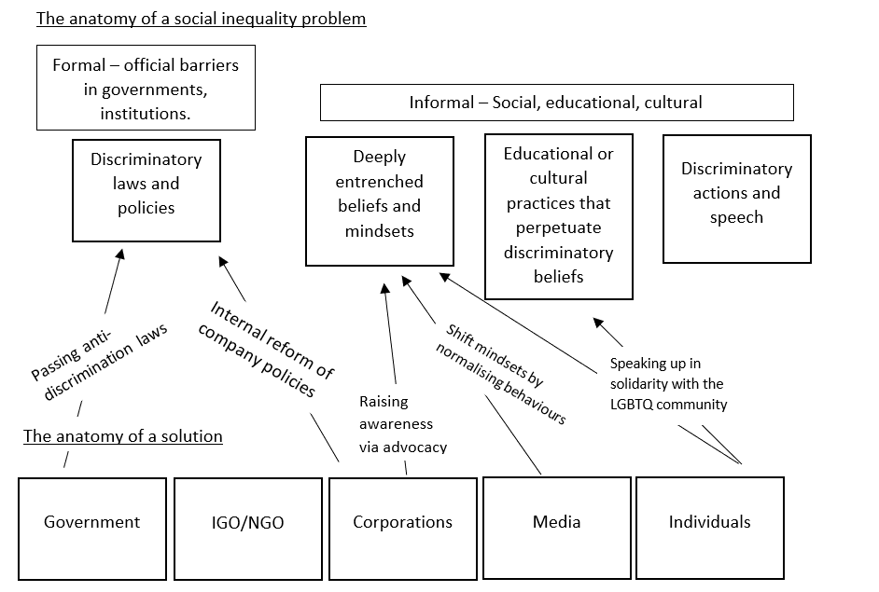
The multi-faceted problem of LGBTQ discrimination and the correspondingly multi-layered solution to this problem can be distilled into a helpful conceptual framework. Notice how the causes of a particular case of social inequality can be divided into formal and informal causes. Formal cases are official barriers to equality –laws and institutional/corporate policies that discriminate against particular groups. Informal categories include discriminatory social, cultural, psychological and behavioral tendencies. Solutions to social inequalities resolve one or more such barriers to inequality. Notably, various stakeholders in society will have varying abilities to effect change and target these causes of inequality. As such, you can illustrate how a solution works by laying out various stakeholders (using the GINCI framework – governments, inter- and non-governmental organisations, corporations, individuals) and indicating the impact they have in alleviating some of these barriers to equality.

This conceptual framework can be replicated for other case studies involving social inequalities. Break down the various dimensions of the reasons for inequality into formal barriers and informal barriers to equality. Next, using the GINCI framework suggest ways in which these various stakeholders and institutions in society have the ability to intervene and list specific impacts they may have.

Case Study 2: Greater Gender Equality in Sports
Over the years, the International Olympic Committee (IOC) has fought for greater inclusion of women in sports. Sports that were traditionally considered male domains were broadened to include women. Wrestling and boxing had their first female Olympic competitions in 2004 and 2012 respectively. In 2018, the Buenos Aires Youth Olympic Games made history for its equal representation of male and female competitors (1,893 women and 1,893 men). The IOC also amended its protocol to allow national teams to appoint a man and a woman as their flag bearers at the opening ceremony for the Tokyo Olympics, to send a message of gender parity.

In tennis, the U.S. Open was the first of four major tennis tournaments to award men and women equal prize money in 1973. The oldest tennis tournament in the sport’s history, Wimbledon, didn’t pay men and women equally until 2007. However, outside of the Grand Slam events, The New York Times reported in 2016 that the annual prize money for the top 100 earners in the Women’s Tennis Association (WTA) was still roughly 80 cents to every dollar earned by the top 100 men in the Association of Tennis Professionals (ATP).

Problems
Although women's presence and involvement in the Olympic Movement have progressively evolved, girls and women across the world still get fewer opportunities and less investment, training and corporate attention when they play sport. While the number of women actively involved in sport has increased dramatically over the past 50 years, female coaches across the globe are a still statistical minority in nearly all sports, at all performance levels. In Europe, between 20 % and 30 % of all sports coaches are women. Even though the gender pay gap in sport has been narrowing over the years, it still exists. A total of 83 % of sports now award men and women equal prize money, with cricket, golf and football displaying the greatest pay gaps.

There are also still significant differences in the media coverage of women's and men's sports. Research shows that sports journalism in the print media is a man's world, with over 90 % of the articles being written by male journalists and more than 85 % of the coverage being dedicated to male athletes. Representation of female athletes in the media also tend to be unduly focused on their appearance. After being dropped by long-time sponsor Billabong in 2016, Rebecca Woods, a former top 10 surfer, spoke out against sponsors who ignore female talent in favour of model looks.”I didn’t particularly feel like I wanted to get naked to become more famous,” she told ABC.

Case Study 3: Greater Equality for Indigenous People (Malaysia’s Bumiputra Policy)
Malaysia’s New Economic Policy or ‘Bumiputra’ policy was introduced in the 1970s to help defuse ethnic tensions following the deadly race riots in 1969 and to also address the problems of poverty faced by the bumiputras*.

The government took affirmative action* to increase the social standing of Malays and indigenous people by having quotas in the granting of scholarships, positions in the civil service, and business licences, as well as native reservations of land. For example, all Bumiputras, regardless of their financial standing, would be entitled to a 7 percent discount on houses or property, including luxurious units; whereas a low-income non-Bumiputra would receive no such financial benefits or assistance.

*bumiputra ethnic group: This concept was initially coined by Abdul Razak Hussein, former Prime Minister of Malaysia. It recognised the “special position” of the Malays provided in the Constitution of Malaysia, in particular Article 153. However, the constitution does not use the term bumiputra; it defines only "Malay" and "indigenous peoples".

Problems
While the Bumiputra policy began with good intentions (it aimed to improve the economic status of the bumiputra, the poorest demographic) it had the effect of causing reverse discrimination, as the bumiputra’s quality of the life was promoted at the expense of other ethnic minorities.

This reverse discrimination has caused resentment among the excluded communities, mainly the Chinese and Indian minorities. In Malaysia’s higher education system, students from the Chinese and Indian ethnic groups have been denied places in universities even though their results clearly meet the cut-off. Excluded communities have appealed to the government to steer away from race-based policies towards a needs-based strategy, to reduce inequality and elevate the position of the poor. While the state claims that it is attempting to move away from race-based policies benefitting the bumiputras, these moves seem to have limited success. A study of several public and government-funded Malaysian universities reveals that although the number of university applicants remained steady, student intakes for the Chinese and Indian ethnic minority groups are in fact declining.

Case Study 4: Singapore’s efforts to address issues of social inequality in society
Through Legislation
Article 12 of the Constitution of the Republic of Singapore guarantees to all persons equality before the law and equal law protection. The Article identifies four forbidden classifications – religion, race, descent and place of birth – upon which Singapore citizens may not be discriminated against in conducting any trade, business, profession or employment.

- Fair Racial Laws and Representation
In 1970, the Presidential Council for Minority Rights was established to ensure there is no discrimination against any ethnic minority groups within Singaporean law. To ensure adequate minority representation in Parliament, the Group Representation Constituency (GRC) system was put in place in 1988, requiring political parties to field at least one minority candidate (e.g., Malay, Indian, or from other minority ethnic groups) in each GRC team.
- Maintenance of Religious Harmony Act
The Maintenance of Religious Harmony Act is a law that prohibits people from causing feelings of enmity, hatred, ill-will or hostility between different religious groups.
- Maintenance of Racial Harmony Act
The Maintenance of Racial Harmony Act was passed in 2021 to tackle offenses related to racism in a targeted manner and emphasises the importance of racial harmony in Singapore.
- Women’s Charter
The Women’s Charter is designed to improve and protect the rights of females in Singapore and to guarantee greater legal equality for women in legally sanctioned relationships (except in the area of Muslim marriages, which are governed separately by the Administration of Muslim Law Act). The Act provides for the institution of monogamous marriages, the rights of husbands and wives in marriage, the protection of the family, and legal potentialities regarding divorce and separation.
- Penal Code and Homosexuality
On 29 November 2022, Section 377A of the Penal Code, a law that criminalised homosexual sex between men, was repealed. In discussing this milestone in Singapore’s history, Prime Minister Lee Hsien Loong commented, “The outcome itself is significant. We are decriminalising sex between men – a longstanding issue, and not just for gay Singaporeans. At the same time we are protecting the definition of marriage – as a union between a man and a woman – from Constitutional challenge.”
Through Social Integration
Another approach is social and cultural integration, where minority groups such as ethnic minorities, and underprivileged sections of a society move into the mainstream of societies. It does not require the minority groups to give up their culture, but it may require them to forgo some aspects of their culture which are inconsistent with the laws and values of the society. In tolerant and open societies, members of minority groups can often use social integration to gain full access to the opportunities, rights and services available to the mainstream members of society.
- People’s Association’s (PA) Integration and Naturalisation Champions Programme in Singapore
The programme has helped new citizens settle in the community, providing platforms for them to interact and bond with the local residents. Their efforts have helped people to make friends, develop mutual understanding, and begin to build social networks.

- PA’s Racial Harmony Programmes
Many local-level racial harmony programmes are organised by the grassroots organisations to raise the level of understanding amongst neighbours of different races. In recent years, more focus has been given to programmes that encourage community participation to deepen inter-racial understanding among residents. Some efforts include bringing residents from various races and ethnic groups together to develop and organise racial harmony programmes.

- Ethnic Integration Policy for Housing Development Board (HDB) Flats Buyers
The Ethnic Integration Policy aims to promote racial integration and harmony. It also seeks to prevent the formation of racial enclaves by ensuring a balanced ethnic mix among the various ethnic communities living in public housing estates.
Reflection question: As our society becomes more diverse, social inequality seems inevitable. How do you think the measures to mitigate such a situation will need to be improved or strengthened?

Example of an essay question:
Evaluate the claim that equality of opportunity for females is a desirable, but unrealistic goal. (2016 A- levels)

SECTION 5. KEYWORD FOCUS: Harms/ Benefits

Social Inequality Question:
‘Discrimination is always harmful.’ Discuss.
Terms used | Possible clarification and definition of terms
Discrimination | The treatment of, or making a distinction in favour of or against, a person or thing solely based on the group to which that person belongs rather than on individual merit.
Always | On ALL occasions, without fail
Harmful | Damaging impact

Recap: How do I show that something is ‘beneficial’ or ‘harmful in my writing?

1. Clear demonstration of how the subject matter causes the impact [Assumption: Discrimination is often viewed negatively by the majority.]
2. Clear demonstration of the significance of the impact by reference to (why so impactful, so what): [Value-Impact Question]
a. Severity, Scale, Frequency (S,A,T) – affecting which Stakeholders, aspects, time frame
b. Features of the world (L) – affecting which level
c. Essential features of humanity (L) - affecting which level

Stakeholders – parties involved
Aspects – SPERM
Levels – individual, community, national, regional, global
Time – past vs present, short vs long-term, change vs continuity, long-drawn vs catalyst

Common Mistake: There is a mismatch between TS, and example chosen to support it.

Very often, students’ examples are relevant to the subject matter, but does not fully illustrate the cause and effect identified in the Topic Sentence.

1) Identify the cause and effect outlined in the topic sentence.
2) Which of the following examples and their accompanying explanation clarifies the cause and effect in the topic sentence given? Provide a reason for your answer.

Question: ‘Discrimination is always harmful.’ Discuss.
Topic Sentence | Example+ Explanation | Reason:
More often than not, detrimental consequences of discrimination have a spill over effect on the victims, which continue to cast a gloom upon society at large. [yellow – impact] | (A) Deeply entrenched sexism in Japan means that women in the workplace face many challenges. Working mothers have few role models in managerial posts and women often found themselves discriminated against after having children. This discrimination against women at the workplace ultimately affects Japanese society as a whole because declining birth rate has created labour shortages, but workplaces often demand long hours and overtime – a difficult prospect for female employees in a society that often still expects women to take the lead on housework and childcare. This leaves many women feeling forced to quit their jobs to have children or forego a family to stay employed and get promoted. | √ Eg describes how sexism in the workplace has negative consequences that is not limited to just the individual, but also worsens the nation’s labour shortage problem.
 | (B) The United States’ long-standing oppression of black individuals is magnified in states such as Wisconsin, where there is more significant residential segregation between blacks and whites. This has the effect of worsening implicit bias (the way people of all races subconsciously internalise ideas about the dangers of certain racial groups). As a result, segregated black neighourhoods tend to be more heavily policed than others, which results in greater run ins between black individuals and the police.  [Improved]  The US urban development has demonstrated much segregation between the various races, especially between the blacks and the whites, leading to an increased inability of these two groups to inter-mingle and forge understanding and acceptance between them. The socio-economic disparities between them further exacerbated the perceptions that the Black residential areas and communities are characterised with heavier crimes and more conflicts between the police and the black communities, leading to a dominant perception that USA, especially in the areas dominated by Black residents, is unsafe and chaotic. | X Eg focuses on how historical factors affecting discrimination are further enforced by the geographical distribution of population. Has not gone on to show how negative consequences of discrimination extend beyond the individuals involved.

